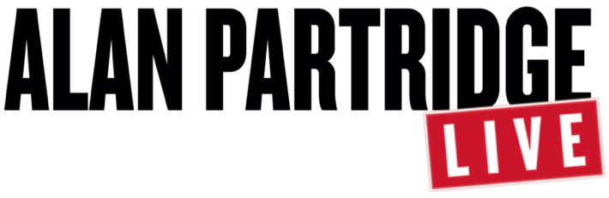

‘STRATAGEM WITH ALAN PARTRIDGE’ LIVE STAGE SHOW STARRING STEVE COOGAN LAUNCHING IN SPRING 2022 ACROSS THE UK AND IRELAND

TICKETS ON SALE NOW FROM ALANPARTRIDGELIVE.COM, TICKETMASTER.CO.UK AND TICKETMASTER.IE*

Photographer credit: Trevor Leighton

LONDON, UK: STRATAGEM WITH ALAN PARTRIDGE, a live stage show starring the award-winning multi-hyphenate Steve Coogan will launch this Spring 2022 across the UK and Ireland, with tickets on sale now at alanpartridgelive.com, ticketmaster.co.uk and ticketmaster.ie.

Love him or loathe him, we all love Alan Partridge.

Over a multi-decade broadcasting career, this wonderful and surprisingly well-read man has brought delight to millions. And now, in a country riven with discord and disease, Alan is touring the country with a message of hope.

Welcome to STRATAGEM WITH ALAN PARTRIDGE, a live stage show that promises to inform, educate and entertain in approximately equal measure.

Wearing a head-mic favoured by TED talkers, market hawkers, TV evangelists, backing singers and carnival barkers, Alan combines all these roles and more. It’s a manifesto for the way we can move forward, a roadmap to a better tomorrow, an ABC for the way to be.
Devised, written, choreographed, performed, and funded by Alan Partridge, Stratagem sees Alan not just treading the boards but pounding them, atop stages graced by such luminaries as Michael Ball, Jack Whitehall and Welsh rockers the Stereophonics.

So join Alan, live on stage, (though patrons are asked not to join Alan live on stage) as he brings STRATAGEM to a city or selected good-sized town near you.

The show is produced by Phil McIntyre Live Ltd and Baby Cow Productions and written by Steve Coogan, Neil Gibbons and Rob Gibbons.

Tickets can be purchased at alanpartridgelive.com, ticketmaster.co.uk and https://www.ticketmaster.ie/.*

*For Ireland venues only.

Full tour dates are included below:

22/04/22
Belfast, SSE Arena

23/04/22
Dublin, 3 Arena

24/04/22
Dublin, 3 Arena

26/04/22
Edinburgh, Playhouse

28/04/22 & 29/04/22
Birmingham, Utilita Arena
30/04/22
Sheffield, Sheffield Arena

03/05/22 & 04/05/22
Newcastle, Utilita Arena

05/05/22
Hull, Bonus Arena
06/05/22 & 07/05/22
Nottingham, Motorpoint Arena

08/05/22 & 09/05/22
Brighton Centre

11/05/22
Liverpool, M&S Bank Arena

13/05/22 & 14/05/22
Manchester Arena

15/05/22
Hull, Bonus Arena

17/05/22
Blackpool, Grand Opera House

18/05/22
Plymouth Pavilions

19/05/22 – 21/05/22
Cardiff, Motorpoint Arena

22/05/22
Bournemouth, BIC
24/05/22 & 25/05/22
Glasgow, SSE Arena

26/05/22
Edinburgh, Playhouse

27/05/22
Aberdeen, P&J Live

28/05/22 & 29/05/22
Leeds, First Direct Arena

31/05/22, 01/06/22 & 03/06/22
London, The O2

Assets:

Trailer here: https://youtu.be/UpdzyMbJM2c

Link to hi-res images: https://we.tl/t-3GPZZomf2e

Website and social media information:

Official website: Alanpartridgelive.com

Twitter: @PartridgeLive
Instagram: @AlanPartridgeLive
Facebook: @AlanPartridgeLive

Media contact:
Will Wood: will.wood@multitudemedia.co.uk, 07817014515
Karma Symington: karma.symington@multitudemedia.co.uk, 07960663599

